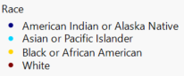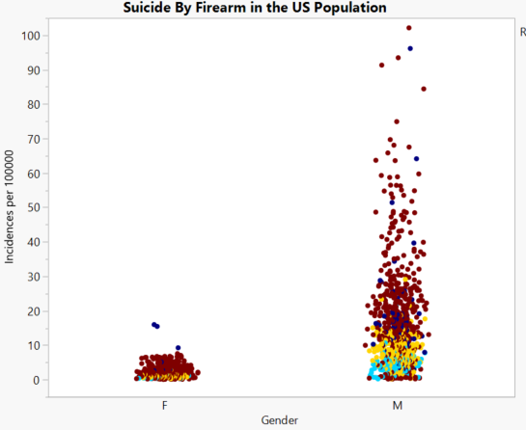

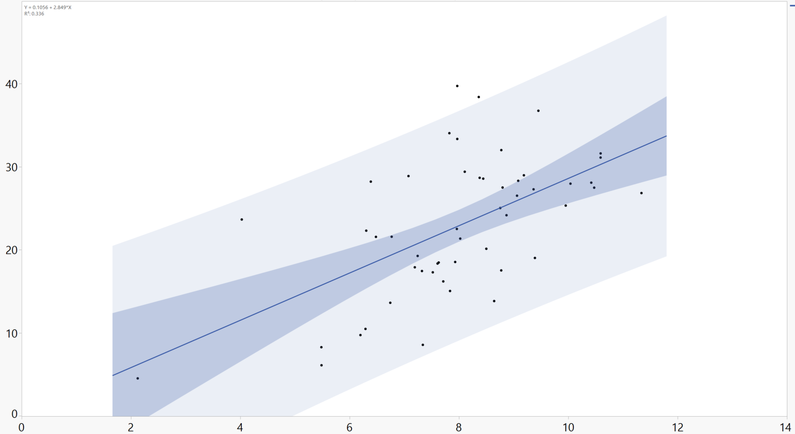

**Y=0.1056+2.849X**

**R2=0.336**

Number of Votes for Trump per 100 White Men Per State in 2016 Election

Number of Suicide by FireArm per

100000 White Men Per State in 1997-2017